Software engineering for big data analaysis

CSA-1035

EXP NO:- 21

21. using Raptor- Draw the flowchart to check whether the given number is a palindrome or not. This scenario is a word, number, phrase, or other sequence of symbols that reads the same backwards as forwards. AdaptA method for this problem is to reverse digits of number, compare the reverse of number. If both are same, then return true, else false using Raptor tool.

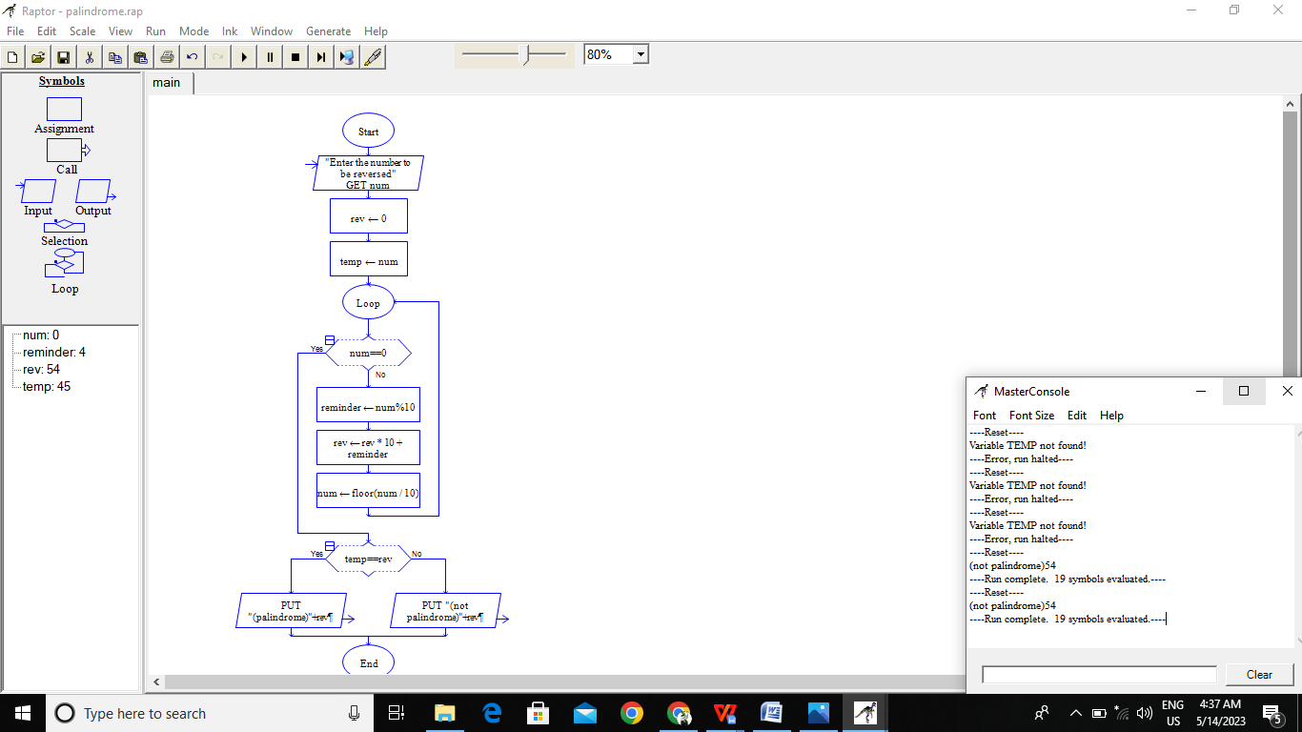

RESULT:-

BY Using Raptor for the given string palindrome or not is verified successfully